Viraj Desai – 210905019

1. Design network configuration shown in Figure 5.29 for all parts. Connect all four VMs to a
single Ethernet segment via a single hub as shown in Figure 5.29. Configure the IP addresses for
the PCs as shown in Table 6.1.
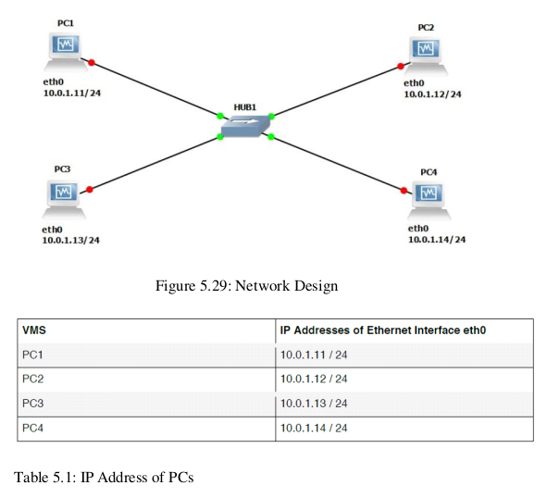
a. On PC1, view the ARP cache with show arp
b. Start Wireshark on PC1-Hub1 link with a capture filter set to the IP address of PC2.
c. Issue a ping command from PC1 to PC2:
PC1% ping 10.0.1.13 –c 3
Observe the ARP packets in the Wireshark window. Explore the MAC addresses in the
Ethernet headers of the captured packets.
Direct our attention to the following fields
d) View the ARP cache again with the command arp -a. Note that ARP cache entries can get
refreshed/deleted fairly quickly

Ans)
a.
00:50:79:66:68:01 10.1.1.11 expires in 58 seconds

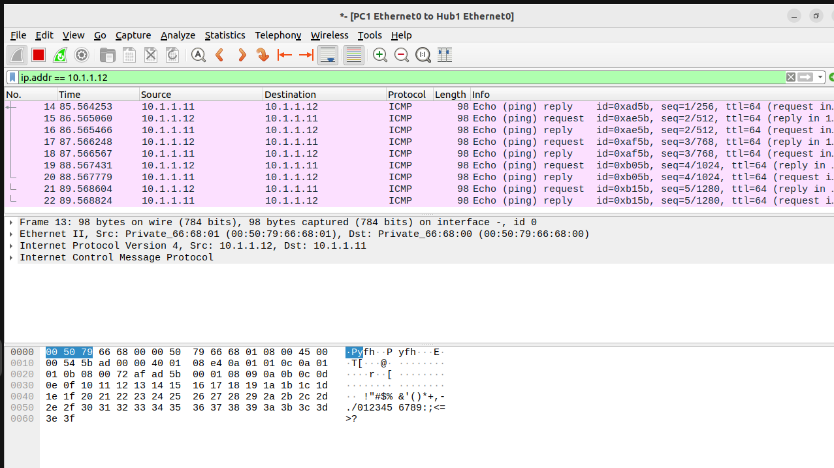
b. c.
Frame 13: 98 bytes on wire (784 bits), 98 bytes captured (784 bits) on interface -, id 0
Ethernet II, Src: Private_66:68:01 (00:50:79:66:68:01), Dst: Private_66:68:00 (00:50:79:66:68:00)
Destination: Private_66:68:00 (00:50:79:66:68:00)
Source: Private_66:68:01 (00:50:79:66:68:01)
Type: IPv4 (0x0800)
Internet Protocol Version 4, Src: 10.1.1.12, Dst: 10.1.1.11
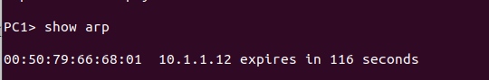
Internet Control Message Protocol
d)

2. To observe the effects of having more than one host with the same (duplicate) IP address
in a network.
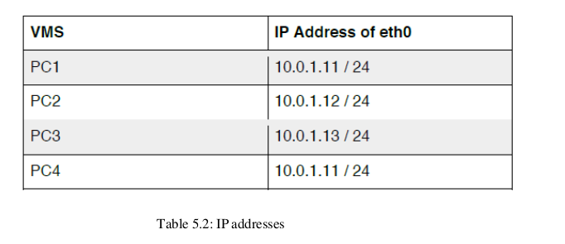
After completing Exercise 1, the IP addresses of the Ethernet interfaces on the four PCs are as
shown in Table 5.2 above. Note that PC1 and PC4 are assigned the same IP address.

a. Delete all entries in the ARP cache on all PCs.
b. Run Wireshark on PC3-Hub1 link and capture the network traffic to and from the duplicate IP
address 10.0.1.11.
c. From PC3, issue a ping command to the duplicate IP address, 10.0.1.11, by typing
PC3% ping 10.0.1.11 –c 5
d. Stop Wireshark, save all ARP packets and screenshot the ARP cache of PC3 using
the arp –a command:
PC3% arp – a
e. When you are done with the exercise, reset the IP address of PC4 to its original value as given
in Table 6.1.

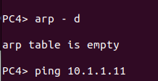
a)

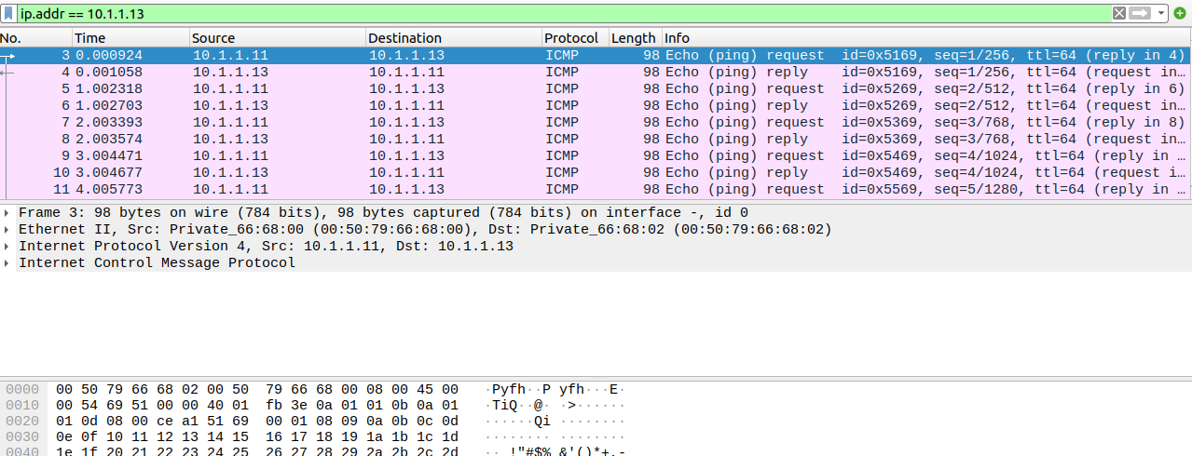
b)

Ethernet II, Src: Private_66:68:01 (00:50:79:66:68:00), Dst: Private_66:68:00 (00:50:79:66:68:02)
Destination: Private_66:68:00 (00:50:79:66:68:02)
Source: Private_66:68:01 (00:50:79:66:68:00)
Type: IPv4 (0x0800)
Internet Protocol Version 4, Src: 10.1.1.11, Dst: 10.1.1.13
Internet Control Message Protocol
Ethernet II, Src: Private_66:68:01 (00:50:79:66:68:02), Dst: Private_66:68:00 (00:50:79:66:68:00)
Destination: Private_66:68:00 (00:50:79:66:68:00)
Source: Private_66:68:01 (00:50:79:66:68:02)
Type: IPv4 (0x0800)
Internet Protocol Version 4, Src: 10.1.1.13, Dst: 10.1.1.11
Internet Control Message Protocol
c)
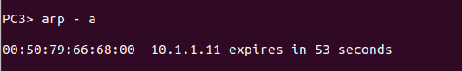
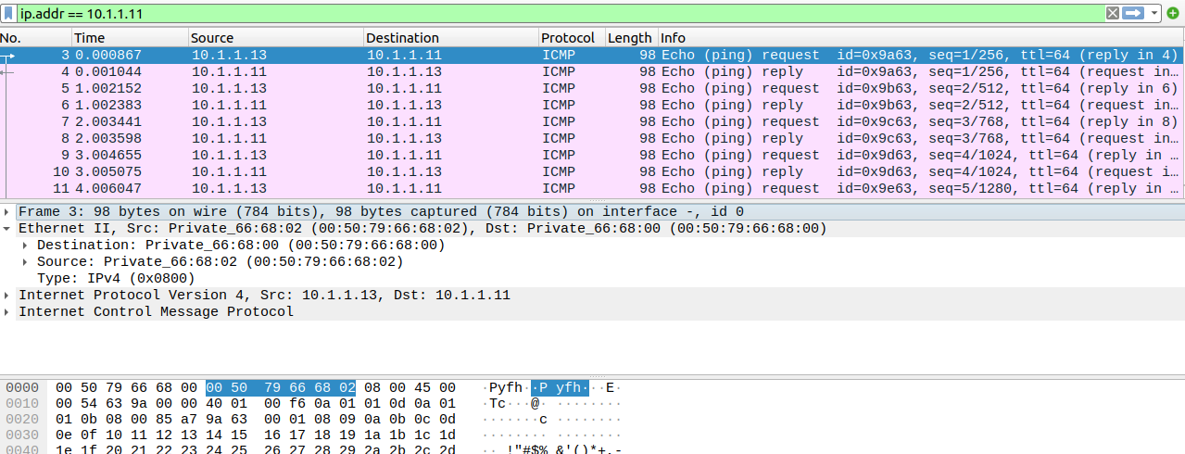

d)

3. To test the effects of changing the netmask of a network configuration.
a. Design the configuration as Exercise 1 and replace the hub with a switch, two hosts (PC2
and PC4) have been assigned different network prefixes.
Setup the interfaces of the hosts as follows:
VPCS IP Address of eth0 Network Mask
PC110.0.1.100 / 24255.255.255.0
PC210.0.1.101 / 28255.255.255.240
PC310.0.1.120 / 24255.255.255.0
PC410.0.1.121 / 28255.255.255.240
b. Run Wireshark on PC1-Hub1 link and capture the packets for the following scenarios
i. From PC1 ping PC3.
ii. From PC1 ping PC2.
iii. From PC1 ping PC4.
iv. From PC4 ping PC1.
v. From PC2 ping PC4.
vi. From PC2 ping PC3.
c. Save the Wireshark output to a text file (using the “Packet Summary” option from “Print”) ,
and save the output of the ping commands. Note that not all of the above scenarios are
successful. Save all the output including any error messages.
d. When you are done with the exercise, reset the interfaces to their original values as given
Table 6.1. (Note that /24 corresponds to network mask 255.255.255.0. and /28 to network
mask 255.255.255.240).

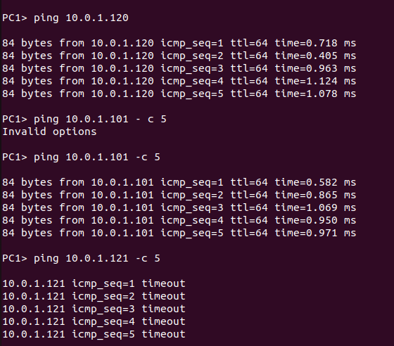

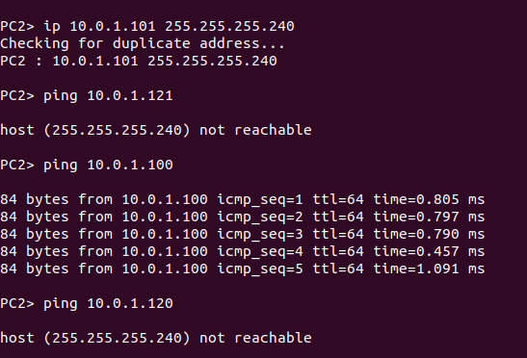

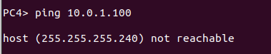

Based On Lab Question 1
• What is the destination MAC address of an ARP Request packet?
00:50:79:66:68:00
• What are the different Type Field values in the Ethernet headers that you observed?
Ethernet II, Src: Private_66:68:01 (00:50:79:66:68:01), Dst: Private_66:68:00 (00:50:79:66:68:00)
Destination: Private_66:68:00 (00:50:79:66:68:00)
Source: Private_66:68:01 (00:50:79:66:68:01)
Type: IPv4 (0x0800)
Internet Protocol Version 4, Src: 10.1.1.12, Dst: 10.1.1.11
Internet Control Message Protocol
• Use the captured data to analyze the process in which ARP acquires the MAC address for IP
address 10.0.1.12.
1.ARP Request: A device wants to find the MAC address of the device with IP address 10.0.1.12. It sends an ARP Request packet with its own MAC and IP addresses and the target IP address (10.0.1.12) with an unknown MAC address. The destination MAC address in the Ethernet frame is the broadcast address (FF:FF:FF:FF:FF:FF).
2.ARP Response: The device with IP address 10.0.1.12 recognizes its IP address in the ARP Request. It sends an ARP Response packet containing its own MAC address (00:50:79:66:68:01) and IP address back to the requesting device. The destination MAC address in the Ethernet frame is set to the requesting device's MAC address.
3.Updating ARP Cache: The requesting device receives the ARP Response, extracts the MAC address (00:50:79:66:68:01), and updates its ARP cache to associate it with IP address 10.0.1.12. This allows the device to communicate directly with the device at that IP address on the local network.

Based On Lab Question 2
• Explain how the ping packets were issued by the hosts with duplicate addresses.
The duplicating and sharing of the addresses did not work.
• Did the ping command result in error messages?
The ping command worked as the duplication failed
• How can duplicate IP addresses be used to compromise the data security?
Duplicate IP addresses can compromise data security by enabling IP spoofing, where attackers send packets with falsified source addresses to deceive recipients.
- For example, an attacker can send ARP packets with a duplicate IP address, causing incorrect entries in the target's ARP cache. This can redirect traffic to the attacker's device.
• Give an example. Use the ARP cache and the captured packets to support your explanation.
Based On Lab Question 3
• Use your output data and ping results to explain what happened in each of the ping commands.
• Which ping operations were successful and which were unsuccessful? Why?

- In a ping command analysis:
  - Ping from Device pc3 to duplicate IP may succeed, but data goes to the wrong device.
  - Ping from Device pc1 to its duplicate IP will likely succeed due to correct ARP cache.
  - Ping from Device pc2 to its duplicate IP will also likely succeed.
Based On Lab Question 3
• Use your output data and ping results to explain what happened in each of the ping commands.
• Which ping operations were successful and which were unsuccessful? Why?

i. From PC1 ping PC3. - successful
ii. From PC1 ping PC2.- successful
iii. From PC1 ping PC4.- timeout
iv. From PC4 ping PC1.- not reachable
v. From PC2 ping PC4.- not reachable
Either the machine does not exist on the network or we are trying to connect 2 different networks.

